

Reliabilty Videogame

Proyecto integrador

The last kingdom

integrantes

René Hagi botello casas (CIB)

Luis alberto pérez Contreras (CIB)

Jennifer esmeralda covarrubias macias (ANI)

Georgina Elena Franco Carrillo (ani)

QUINTO SEMESTRE

2014

# Datos del Proyecto

Idea general.

Hoy en día el maltrato infantil, de cualquier tipo, es un problema bastante frecuente en nuestra sociedad por lo que la creación de herramientas nuevas e innovadoras son de suma urgencia. Normalmente la detección de esta problemática es relativamente sencilla por algún experto en la materia pero, el verdadero problema no es este, es prevenir o tratar a los niños que sufrieron algún tipo de agresión física o moral.

Lo que estamos planteando es crear un videojuego capaz de dotar al usuario, en este caso un niño, de herramientas suficientes para normalizar su vida, ya que, aquellos que padecen de esta situación terminan por cometer las mismas acciones o son orillados a cometer actos delictivos y, en algunos casos, el suicidio.

Objetivo.

Implementar un software capaz de ayudar en la rehabilitación de los niños que hayan sufrido maltrato por medio de una herramienta simple, divertida y educativa, que permita su reintegración a la sociedad sin generar muchas complicaciones.

Profesores encargados.

|  |  |  |
| --- | --- | --- |
| Nombre | Materia | Correo |
| Waldo Daniel Cambrón | Game Design | [waldo@elyongames.com](mailto:waldo@elyongames.com) |
| Jimena Reyes Silva | Interpretación de la Realidad Socioeconómica Política y Cultural | [jimena.reyes88@gmail.com](mailto:jimena.reyes88@gmail.com) |
| Guadalupe Maricela Cornejo Martínez | Ingeniería de Software | [maricela_cornejo@yahoo.com.mx](mailto:maricela_cornejo@yahoo.com.mx) |

Entrega de Avances.

En caso de haber avances significativos se entregará un reporte cada martes de todas las semanas hasta terminar el proyecto.

Integrantes.

|  |  |  |
| --- | --- | --- |
| Nombre | Tareas a realizar | Carrera |
| René Hagi Botello Casas. | Programación y organización del software. | Cibernética y Sistemas Computacionales. |
| Luis Alberto Pérez Contreras. | Programación y organización del software. | Cibernética y Sistemas Computacionales. |
| Jennifer Esmeralda Covarrubias Macias. | Creación del plan de negocios y animaciones 3D. | Animación y Desarrollo de Videojuegos. |
| Georgina Elena Franco Carrillo. | Arte: sketches, diseño de personajes y elementos visuales. | Animación y Desarrollo de Videojuegos. |

Herramientas a usar.

* **Programa o Engine:** Unity 3D.
* **Lenguaje a usar:** C#
* **Programa para administración:** Microsoft Project 2013.
* **Comunicación:** Trello.

Tiempo estimado del proyecto.

6 meses para un demo y aproximadamente 1 año para terminarlo.

# Planeación:

## Plan de seguimiento / ciclo de vida (Cascada y Prototipado).

Para el proyecto se utilizarán dos metodologías de planeación de proyectos, con esto aseguramos que el videojuego está bien sustentado y no cometeremos errores graves en el futuro. Los modelos a utilizar serán los siguientes:

* Cascada

Con este tipo de ciclo de vida podemos desarrollar el proyecto de manera sencilla siguiendo secuencialmente los pasos que se describirán al final de la sección. Primero se tendrá que realizar una investigación que dará los requerimientos necesarios para comenzar la planeación del software; requerimiento y análisis, diseño, codificación, pruebas y, por último, la aprobación.

* Prototipado:

Se realizará el proceso anterior, sin embargo este es de manera cíclica., ya que se está realizando un software a la medida y es poco probable que en el momento de la aprobación no surjan detalles vistos por el experto. Por lo que al llegar al punto de aprobación vamos a reiniciar el ciclo tomando en cuenta los comentarios obtenidos anteriormente; con esto aseguramos que el videojuego tenga una calidad y éxito mayor.

## Mapa mental del proyecto:

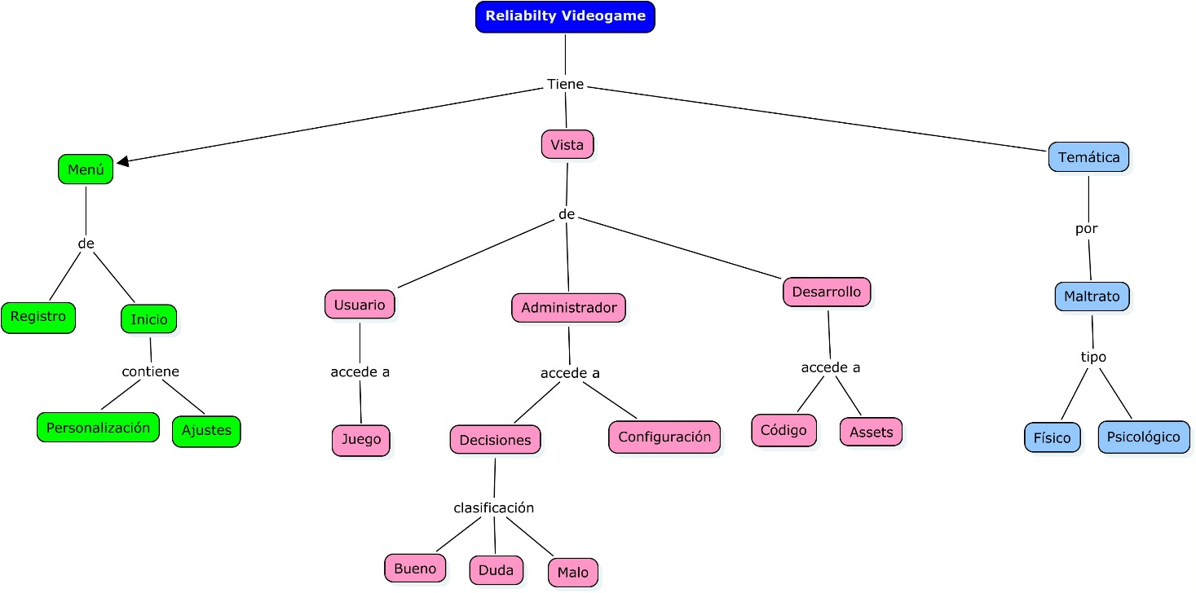

## Diagrama de Contexto:

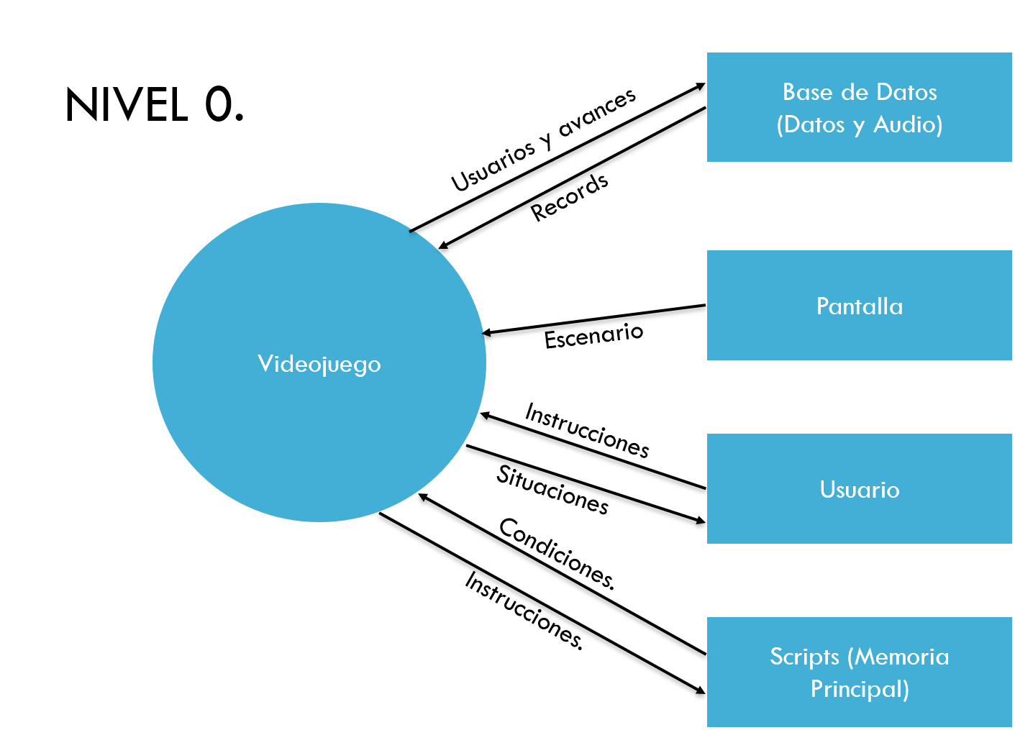

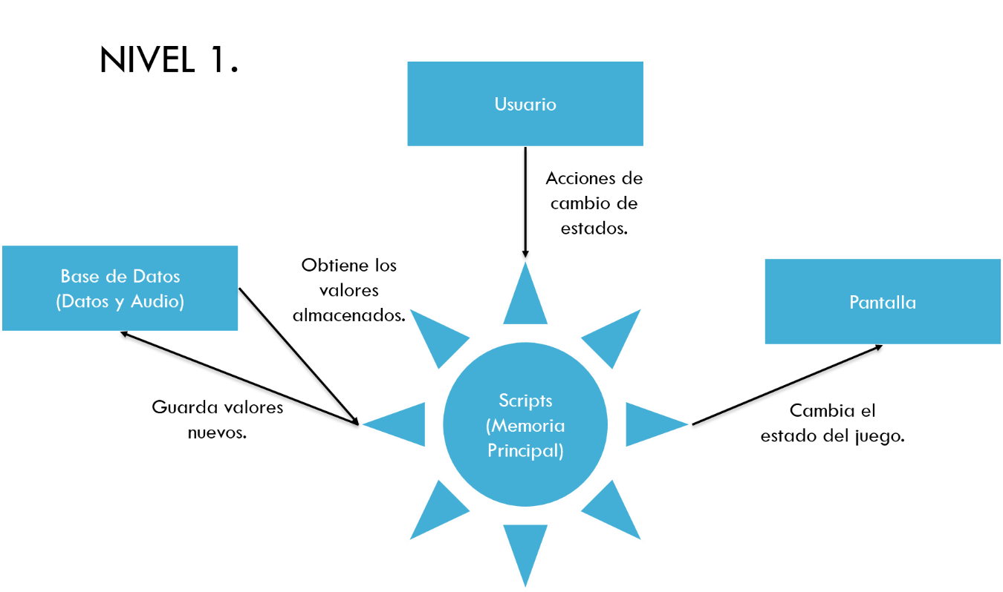

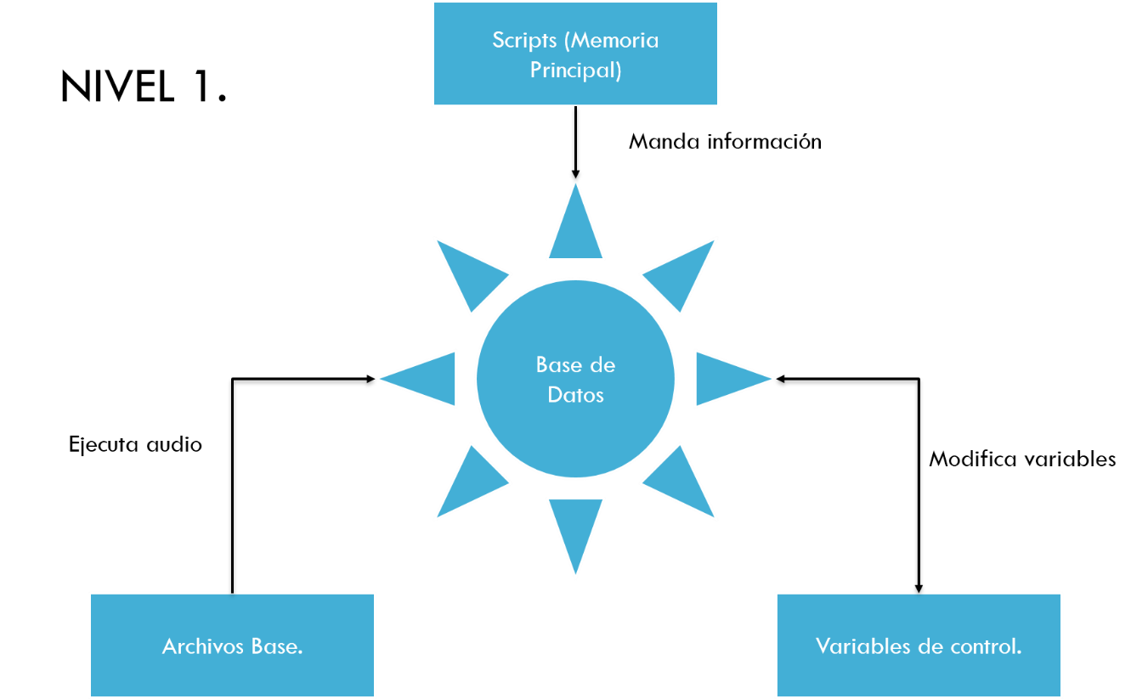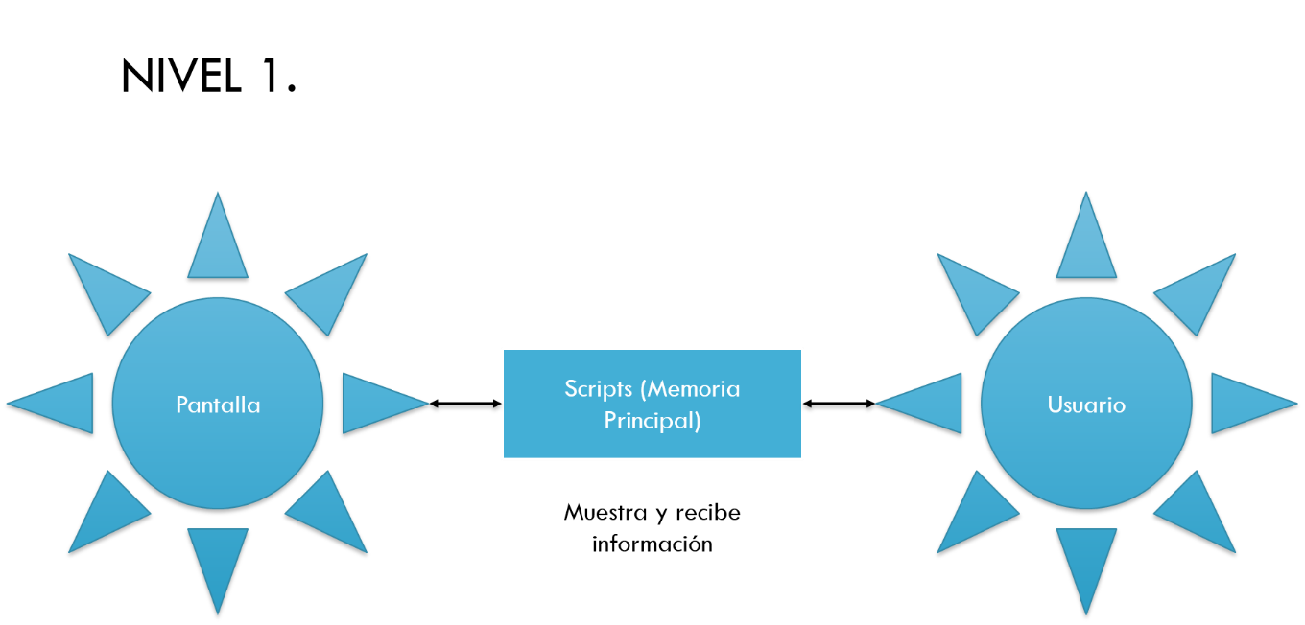

# Diagrama de casos de usos

# Casos de USO

|  |  |  |  |
| --- | --- | --- | --- |
| Use Case ID: | 0 | | |
| Use Case Name: | Botón de inicio | | |
| Created By: | René Hagi, Luis Pérez, Jennifer Esmeralda, Georgina Franco. | Last Updated By: |  |
| Date Created: | 26/09/2014 | Date Last Updated: |  |
| Actors: | Jugador | | |
| Description: | El Jugador Presiona el botón de inicio e inicia la aplicación. | | |
| Trigger: | Se dispara cuando el jugador presiona el botón de inicio. | | |
| Preconditions: | Es necesario que el dispositivo esté encendido y el juego instalado. | | |
| Postconditions: | Se comienza a cargar la memoria. | | |
| Normal Flow: | |  |  |  |  |  |  |  |  | | --- | --- | --- | --- | --- | --- | --- | --- | | Paso | Acción | Input | Format | Exit | Format | Result | Ok/nOk | | 1 | Presionar Botón de iniciar | Botón de inicio | Event | Menú -mensajes | Imagen | Carga la memoria |  | | | |
| Alternative Flows: | En caso de que el juego no inicie es necesario mandar un mensaje de error. | | |
| Exceptions: |  | | |
| Includes: |  | | |
| Priority: | 1 | | |
| Frequency of Use: | Siempre. | | |
| Business Rules: | El juego solo corre si está instalado correctamente. | | |
| Special Requirements: |  | | |
| Assumptions: |  | | |
| Notes and Issues: |  | | |
|  | | | |
| Use Case ID: | 1 | | |
| Use Case Name: | Cargar memoria. | | |
| Created By: | René Hagi, Luis Pérez, Jennifer Esmeralda, Georgina Franco. | Last Updated By: |  |
| Date Created: | 26/09/2014 | Date Last Updated: |  |
| Actors: |  | | |
| Description: | Obtener los datos guardados y pasarlos a memoria. | | |
| Trigger: | Se dispara después de que el Jugador presiona el botón de inicio. | | |
| Preconditions: | Que se haya presionado el botón de inicio. | | |
| Postconditions: | Inicia el menú principal. | | |
| Normal Flow: | |  |  |  |  |  |  |  |  | | --- | --- | --- | --- | --- | --- | --- | --- | | Paso | Acción | Input | Format | Exit | Format | Result | Ok/nOk | | 2 | Cargar memoria |  | Proceso |  |  | Menú Principal |  | | | |
| Alternative Flows: | Se manda un mensaje. | | |
| Exceptions: | El juego se inicia sin datos guardados previamente. | | |
| Includes: |  | | |
| Priority: | 2 | | |
| Frequency of Use: | Siempre | | |
| Business Rules: |  | | |
| Special Requirements: |  | | |
| Assumptions: |  | | |
| Notes and Issues: |  | | |

|  |  |  |  |
| --- | --- | --- | --- |
| Use Case ID: | 2 | | |
| Use Case Name: | Main Menu | | |
| Created By: | René Hagi, Luis Pérez, Jennifer Esmeralda, Georgina Franco. | Last Updated By: |  |
| Date Created: | 26/09/2014 | Date Last Updated: |  |
| Actors: |  | | |
| Description: | Mostrar el menú con los elementos: botón Options, Play o Stages. | | |
| Trigger: | Haber cargado la memoria. | | |
| Preconditions: | Que se hubiera intentado cargar memoria. | | |
| Postconditions: | Pasa al evento de algún botón presionado. | | |
| Normal Flow: | |  |  |  |  |  |  |  |  | | --- | --- | --- | --- | --- | --- | --- | --- | | Paso | Acción | Input | Format | Exit | Format | Result | Ok/nOk | | 3 | Elegir algún submenú. |  | Event |  | Imagen | Ejecuta el evento del botón seleccionado. |  | | | |
| Alternative Flows: | Si el menú no carga se manda un mensaje de error. | | |
| Exceptions: |  | | |
| Includes: |  | | |
| Priority: | 1 | | |
| Frequency of Use: | Siempre. | | |
| Business Rules: |  | | |
| Special Requirements: |  | | |
| Assumptions: |  | | |
| Notes and Issues: |  | | |

|  |  |  |  |
| --- | --- | --- | --- |
| Use Case ID: | 3 | | |
| Use Case Name: | Botón Options | | |
| Created By: | René Hagi, Luis Pérez, Jennifer Esmeralda, Georgina Franco. | Last Updated By: |  |
| Date Created: | 26/09/2014 | Date Last Updated: |  |
| Actors: | Jugador | | |
| Description: | Se carga el menú de Options. | | |
| Trigger: | El Jugador presiona el Botón de Options. | | |
| Preconditions: | Haberse cargado el Main Menu. | | |
| Postconditions: | Mostrar los submenús Audio y Video. | | |
| Normal Flow: | |  |  |  |  |  |  |  |  | | --- | --- | --- | --- | --- | --- | --- | --- | | Paso | Acción | Input | Format | Exit | Format | Result | Ok/nOk | | 4 | Presionar botón Options | Botón Options | Event |  | Imagen | Ejecuta el menú de Options |  | | | |
| Alternative Flows: | Si el menú no carga mandar un mensaje de error. | | |
| Exceptions: |  | | |
| Includes: |  | | |
| Priority: | 3 | | |
| Frequency of Use: | Ocasional. | | |
| Business Rules: |  | | |
| Special Requirements: |  | | |
| Assumptions: |  | | |
| Notes and Issues: |  | | |

|  |  |  |  |
| --- | --- | --- | --- |
| Use Case ID: | 4 | | |
| Use Case Name: | Botón Audio. | | |
| Created By: | René Hagi, Luis Pérez, Jennifer Esmeralda, Georgina Franco. | Last Updated By: |  |
| Date Created: | 26/09/2014 | Date Last Updated: |  |
| Actors: | Jugador | | |
| Description: | Se carga el menú de Audio. | | |
| Trigger: | El Jugador presiona el Botón de Audio. | | |
| Preconditions: | Haberse cargado el menú Options. | | |
| Postconditions: | Mostrar los submenús Music y FX. | | |
| Normal Flow: | |  |  |  |  |  |  |  |  | | --- | --- | --- | --- | --- | --- | --- | --- | | Paso | Acción | Input | Format | Exit | Format | Result | Ok/nOk | | 5 | Presionar botón Audio | Botón Audio | Event |  | Imagen | Ejecuta el menú de Audio |  | | | |
| Alternative Flows: | Si el menú no carga mandar un mensaje de error. | | |
| Exceptions: |  | | |
| Includes: |  | | |
| Priority: | 4 | | |
| Frequency of Use: | Ocasional. | | |
| Business Rules: |  | | |
| Special Requirements: |  | | |
| Assumptions: |  | | |
| Notes and Issues: |  | | |

|  |  |  |  |
| --- | --- | --- | --- |
| Use Case ID: | 5 | | |
| Use Case Name: | Botón booleano de Music. | | |
| Created By: | René Hagi, Luis Pérez, Jennifer Esmeralda, Georgina Franco. | Last Updated By: |  |
| Date Created: | 26/09/2014 | Date Last Updated: |  |
| Actors: | Jugador | | |
| Description: | Se activa o desactiva la opción Music. | | |
| Trigger: | El Jugador presiona el Botón de Music. | | |
| Preconditions: | Haberse cargado el menú Audio. | | |
| Postconditions: | Ejecutar el valor del booleano. | | |
| Normal Flow: | |  |  |  |  |  |  |  |  | | --- | --- | --- | --- | --- | --- | --- | --- | | Paso | Acción | Input | Format | Exit | Format | Result | Ok/nOk | | 6 | Presionar botón Music | Botón Music | Event |  | Imagen | Ejecuta el valor del booleano |  | | | |
| Alternative Flows: | Si el valor del booleano no es posible de ejecutar, mandar un mensaje de error. | | |
| Exceptions: |  | | |
| Includes: |  | | |
| Priority: | 5 | | |
| Frequency of Use: | Ocasional. | | |
| Business Rules: |  | | |
| Special Requirements: |  | | |
| Assumptions: |  | | |
| Notes and Issues: |  | | |

|  |  |  |  |
| --- | --- | --- | --- |
| Use Case ID: | 6 | | |
| Use Case Name: | Botón booleano de FX. | | |
| Created By: | René Hagi, Luis Pérez, Jennifer Esmeralda, Georgina Franco. | Last Updated By: |  |
| Date Created: | 26/09/2014 | Date Last Updated: |  |
| Actors: | Jugador | | |
| Description: | Se activa o desactiva la opción FX. | | |
| Trigger: | El Jugador presiona el Botón de FX. | | |
| Preconditions: | Haberse cargado el menú Audio. | | |
| Postconditions: | Ejecutar el valor del booleano. | | |
| Normal Flow: | |  |  |  |  |  |  |  |  | | --- | --- | --- | --- | --- | --- | --- | --- | | Paso | Acción | Input | Format | Exit | Format | Result | Ok/nOk | | 7 | Presionar botón FX | Botón FX | Event |  | Imagen | Ejecuta el valor del booleano |  | | | |
| Alternative Flows: | Si el valor del booleano no es posible de ejecutar, mandar un mensaje de error. | | |
| Exceptions: |  | | |
| Includes: |  | | |
| Priority: | 5 | | |
| Frequency of Use: | Ocasional. | | |
| Business Rules: |  | | |
| Special Requirements: |  | | |
| Assumptions: |  | | |
| Notes and Issues: |  | | |

|  |  |  |  |
| --- | --- | --- | --- |
| Use Case ID: | 7 | | |
| Use Case Name: | Botón Video. | | |
| Created By: | René Hagi, Luis Pérez, Jennifer Esmeralda, Georgina Franco. | Last Updated By: |  |
| Date Created: | 26/09/2014 | Date Last Updated: |  |
| Actors: | Jugador | | |
| Description: | Se carga el menú de Video. | | |
| Trigger: | El Jugador presiona el Botón de Video. | | |
| Preconditions: | Haberse cargado el menú Options. | | |
| Postconditions: | Mostrar el submenú Calidad de video. | | |
| Normal Flow: | |  |  |  |  |  |  |  |  | | --- | --- | --- | --- | --- | --- | --- | --- | | Paso | Acción | Input | Format | Exit | Format | Result | Ok/nOk | | 8 | Presionar botón Video | Botón Video | Event |  | Imagen | Ejecuta el menú de Video |  | | | |
| Alternative Flows: | Si el menú no carga mandar un mensaje de error. | | |
| Exceptions: |  | | |
| Includes: |  | | |
| Priority: | 4 | | |
| Frequency of Use: | Ocasional. | | |
| Business Rules: |  | | |
| Special Requirements: |  | | |
| Assumptions: |  | | |
| Notes and Issues: |  | | |

|  |  |  |  |
| --- | --- | --- | --- |
| Use Case ID: | 8 | | |
| Use Case Name: | Botón booleano de calidad de video. | | |
| Created By: | René Hagi, Luis Pérez, Jennifer Esmeralda, Georgina Franco. | Last Updated By: |  |
| Date Created: | 26/09/2014 | Date Last Updated: |  |
| Actors: | Jugador | | |
| Description: | Se activa o desactiva la opción de calidad de video. | | |
| Trigger: | El Jugador presiona el Botón de calidad de video. | | |
| Preconditions: | Haberse cargado el menú Video. | | |
| Postconditions: | Ejecutar el valor del booleano. | | |
| Normal Flow: | |  |  |  |  |  |  |  |  | | --- | --- | --- | --- | --- | --- | --- | --- | | Paso | Acción | Input | Format | Exit | Format | Result | Ok/nOk | | 7 | Presionar botón de calidad de video | Botón de calidad de video | Event |  | Imagen | Ejecuta el valor del booleano. |  | | | |
| Alternative Flows: | Si el valor del booleano no es posible de ejecutar, mandar un mensaje de error. | | |
| Exceptions: |  | | |
| Includes: |  | | |
| Priority: | 5 | | |
| Frequency of Use: | Ocasional. | | |
| Business Rules: |  | | |
| Special Requirements: |  | | |
| Assumptions: |  | | |
| Notes and Issues: |  | | |

|  |  |  |  |
| --- | --- | --- | --- |
| Use Case ID: | 9 | | |
| Use Case Name: | Botón Play. | | |
| Created By: | René Hagi, Luis Pérez, Jennifer Esmeralda, Georgina Franco. | Last Updated By: |  |
| Date Created: | 26/09/2014 | Date Last Updated: |  |
| Actors: | Jugador | | |
| Description: | Se carga el menú de Play. | | |
| Trigger: | El Jugador presiona el botón de Play. | | |
| Preconditions: | Haberse cargado el Main Menu. | | |
| Postconditions: | Cargar el juego. | | |
| Normal Flow: | |  |  |  |  |  |  |  |  | | --- | --- | --- | --- | --- | --- | --- | --- | | Paso | Acción | Input | Format | Exit | Format | Result | Ok/nOk | | 10 | Presionar botón Play | Botón Play | Event |  | Imagen | Ejecuta el juego. |  | | | |
| Alternative Flows: | Si el menú no carga mandar un mensaje de error. | | |
| Exceptions: |  | | |
| Includes: |  | | |
| Priority: | 1 | | |
| Frequency of Use: | Siempre. | | |
| Business Rules: |  | | |
| Special Requirements: |  | | |
| Assumptions: |  | | |
| Notes and Issues: |  | | |

|  |  |  |  |
| --- | --- | --- | --- |
| Use Case ID: | 10 | | |
| Use Case Name: | Botón Carga Juego. | | |
| Created By: | René Hagi, Luis Pérez, Jennifer Esmeralda, Georgina Franco. | Last Updated By: |  |
| Date Created: | 26/09/2014 | Date Last Updated: |  |
| Actors: | Jugador. | | |
| Description: | Manda llamar a Player, Enemigo, Cerebro, Cámara, Power Up. | | |
| Trigger: | El Jugador presionó el botón de Play. | | |
| Preconditions: | Que el Jugador haya presionado el botón Play. | | |
| Postconditions: | El juego se inicia. | | |
| Normal Flow: | |  |  |  |  |  |  |  |  | | --- | --- | --- | --- | --- | --- | --- | --- | | Paso | Acción | Input | Format | Exit | Format | Result | Ok/nOk | | 11 | Cargar juego |  | Proceso |  |  | Se carga el juego. |  | | | |
| Alternative Flows: | Si el juego no carga, mandar un mensaje de error. | | |
| Exceptions: |  | | |
| Includes: |  | | |
| Priority: | 1 | | |
| Frequency of Use: | Siempre. | | |
| Business Rules: |  | | |
| Special Requirements: |  | | |
| Assumptions: |  | | |
| Notes and Issues: |  | | |

|  |  |  |  |
| --- | --- | --- | --- |
| Use Case ID: | 11 | | |
| Use Case Name: | Player. | | |
| Created By: | René Hagi, Luis Pérez, Jennifer Esmeralda, Georgina Franco. | Last Updated By: |  |
| Date Created: | 26/09/2014 | Date Last Updated: |  |
| Actors: |  | | |
| Description: | Genera el Player principal. | | |
| Trigger: | Haber cargado el juego. | | |
| Preconditions: | Que el juego se haya cargado. | | |
| Postconditions: | Que el Player esté disponible. | | |
| Normal Flow: | |  |  |  |  |  |  |  |  | | --- | --- | --- | --- | --- | --- | --- | --- | | Paso | Acción | Input | Format | Exit | Format | Result | Ok/nOk | | 12 | Cargar elementos de Player |  | Proceso |  |  | Se carga el Player |  | | | |
| Alternative Flows: | Si el Player no se genera correctamente, mandar un mensaje de error. | | |
| Exceptions: |  | | |
| Includes: |  | | |
| Priority: | 1 | | |
| Frequency of Use: | Siempre. | | |
| Business Rules: |  | | |
| Special Requirements: |  | | |
| Assumptions: |  | | |
| Notes and Issues: |  | | |

|  |  |  |  |
| --- | --- | --- | --- |
| Use Case ID: | 12 | | |
| Use Case Name: | Enemigo. | | |
| Created By: | René Hagi, Luis Pérez, Jennifer Esmeralda, Georgina Franco. | Last Updated By: |  |
| Date Created: | 26/09/2014 | Date Last Updated: |  |
| Actors: |  | | |
| Description: | Genera el Enemigo principal. | | |
| Trigger: | Haber cargado el juego. | | |
| Preconditions: | Que el juego se haya cargado. | | |
| Postconditions: | Que el Enemigo esté disponible. | | |
| Normal Flow: | |  |  |  |  |  |  |  |  | | --- | --- | --- | --- | --- | --- | --- | --- | | Paso | Acción | Input | Format | Exit | Format | Result | Ok/nOk | | 13 | Cargar elementos de Enemigo |  | Proceso |  |  | Se carga el Enemigo |  | | | |
| Alternative Flows: | Si el Enemigo no se genera correctamente, mandar un mensaje de error. | | |
| Exceptions: |  | | |
| Includes: |  | | |
| Priority: | 1 | | |
| Frequency of Use: | Siempre. | | |
| Business Rules: |  | | |
| Special Requirements: |  | | |
| Assumptions: |  | | |
| Notes and Issues: |  | | |

|  |  |  |  |
| --- | --- | --- | --- |
| Use Case ID: | 13 | | |
| Use Case Name: | Cerebro. | | |
| Created By: | René Hagi, Luis Pérez, Jennifer Esmeralda, Georgina Franco. | Last Updated By: |  |
| Date Created: | 26/09/2014 | Date Last Updated: |  |
| Actors: |  | | |
| Description: | Genera el Cerebro y sus elementos (GUI, Pantalla de derrota, Pantalla de Victoria). | | |
| Trigger: | Haber cargado el juego. | | |
| Preconditions: | Que el juego se haya cargado. | | |
| Postconditions: | Que el Cerebro esté disponible. | | |
| Normal Flow: | |  |  |  |  |  |  |  |  | | --- | --- | --- | --- | --- | --- | --- | --- | | Paso | Acción | Input | Format | Exit | Format | Result | Ok/nOk | | 14 | Cargar elementos de Cerebro |  | Proceso |  |  | Se carga el Cerebro |  | | | |
| Alternative Flows: | Si el Cerebro no se genera correctamente, mandar un mensaje de error. | | |
| Exceptions: |  | | |
| Includes: |  | | |
| Priority: | 1 | | |
| Frequency of Use: | Siempre. | | |
| Business Rules: |  | | |
| Special Requirements: |  | | |
| Assumptions: |  | | |
| Notes and Issues: |  | | |

|  |  |  |  |
| --- | --- | --- | --- |
| Use Case ID: | 14 | | |
| Use Case Name: | GUI. | | |
| Created By: | René Hagi, Luis Pérez, Jennifer Esmeralda, Georgina Franco. | Last Updated By: |  |
| Date Created: | 26/09/2014 | Date Last Updated: |  |
| Actors: |  | | |
| Description: | Genera el GUI del juego (Timer, Score, Botón Pausa). | | |
| Trigger: | El haber cargado el Cerebro. | | |
| Preconditions: | Que el Cerebro se haya cargado. | | |
| Postconditions: | Que se generen los elementos Timer, Score y Botón Pausa. | | |
| Normal Flow: | |  |  |  |  |  |  |  |  | | --- | --- | --- | --- | --- | --- | --- | --- | | Paso | Acción | Input | Format | Exit | Format | Result | Ok/nOk | | 15 | Cargar y mostrar elementos de GUI |  | Proceso |  |  | Se carga el GUI |  | | | |
| Alternative Flows: | Si el GUI no se genera correctamente, mandar un mensaje de error. | | |
| Exceptions: |  | | |
| Includes: |  | | |
| Priority: | 1 | | |
| Frequency of Use: | Siempre. | | |
| Business Rules: |  | | |
| Special Requirements: |  | | |
| Assumptions: |  | | |
| Notes and Issues: |  | | |

|  |  |  |  |
| --- | --- | --- | --- |
| Use Case ID: | 15 | | |
| Use Case Name: | Timer. | | |
| Created By: | René Hagi, Luis Pérez, Jennifer Esmeralda, Georgina Franco. | Last Updated By: |  |
| Date Created: | 26/09/2014 | Date Last Updated: |  |
| Actors: |  | | |
| Description: | Realiza el conteo de tiempo desde la ejecución del GUI. | | |
| Trigger: | La inicialización de GUI. | | |
| Preconditions: | Que el GUI se haya generado correctamente. | | |
| Postconditions: | Permitir sus datos sean utilizados por otros elementos. | | |
| Normal Flow: | |  |  |  |  |  |  |  |  | | --- | --- | --- | --- | --- | --- | --- | --- | | Paso | Acción | Input | Format | Exit | Format | Result | Ok/nOk | | 16 | Llevar el conteo de tiempo |  | Proceso |  |  | Generar información sobre el tiempo. |  | | | |
| Alternative Flows: | Si el Timer no se genera correctamente, mandar un mensaje de error. | | |
| Exceptions: |  | | |
| Includes: |  | | |
| Priority: | 2 | | |
| Frequency of Use: | Siempre. | | |
| Business Rules: |  | | |
| Special Requirements: |  | | |
| Assumptions: |  | | |
| Notes and Issues: |  | | |

|  |  |  |  |
| --- | --- | --- | --- |
| Use Case ID: | 16 | | |
| Use Case Name: | Score. | | |
| Created By: | René Hagi, Luis Pérez, Jennifer Esmeralda, Georgina Franco. | Last Updated By: |  |
| Date Created: | 26/09/2014 | Date Last Updated: |  |
| Actors: |  | | |
| Description: | Calcula el Score durante el juego. | | |
| Trigger: | Se genera por acción de GUI. | | |
| Preconditions: | Que el GUI se haya generado correctamente. | | |
| Postconditions: | Permitir sus datos sean utilizados por otros elementos. | | |
| Normal Flow: | |  |  |  |  |  |  |  |  | | --- | --- | --- | --- | --- | --- | --- | --- | | Paso | Acción | Input | Format | Exit | Format | Result | Ok/nOk | | 17 | Llevar el conteo del score |  | Proceso |  |  | Generar información sobre el score |  | | | |
| Alternative Flows: | Si el Score no se genera correctamente, mandar un mensaje de error. | | |
| Exceptions: |  | | |
| Includes: |  | | |
| Priority: | 2 | | |
| Frequency of Use: | Siempre. | | |
| Business Rules: |  | | |
| Special Requirements: |  | | |
| Assumptions: |  | | |
| Notes and Issues: |  | | |

|  |  |  |  |
| --- | --- | --- | --- |
| Use Case ID: | 17 | | |
| Use Case Name: | Botón Pausa | | |
| Created By: | René Hagi, Luis Pérez, Jennifer Esmeralda, Georgina Franco. | Last Updated By: |  |
| Date Created: | 26/09/2014 | Date Last Updated: |  |
| Actors: | Jugador | | |
| Description: | Se carga el menú de Pausa. | | |
| Trigger: | El Jugador presiona el botón de Pausa. | | |
| Preconditions: | Que el GUI se haya generado correctamente. | | |
| Postconditions: | Mostrar los submenús Botón Resume, Botón Restart, Botón Options, Botón Quit. | | |
| Normal Flow: | |  |  |  |  |  |  |  |  | | --- | --- | --- | --- | --- | --- | --- | --- | | Paso | Acción | Input | Format | Exit | Format | Result | Ok/nOk | | 18 | Presionar botón Pausa | Botón Pausa | Event |  | Imagen | Ejecuta el menú de Pausa |  | | | |
| Alternative Flows: | Si el menú no carga mandar un mensaje de error. | | |
| Exceptions: |  | | |
| Includes: |  | | |
| Priority: | 2 | | |
| Frequency of Use: | Ocasional. | | |
| Business Rules: |  | | |
| Special Requirements: |  | | |
| Assumptions: |  | | |
| Notes and Issues: |  | | |

|  |  |  |  |
| --- | --- | --- | --- |
| Use Case ID: | 18 | | |
| Use Case Name: | Botón Resume | | |
| Created By: | René Hagi, Luis Pérez, Jennifer Esmeralda, Georgina Franco. | Last Updated By: |  |
| Date Created: | 26/09/2014 | Date Last Updated: |  |
| Actors: | Jugador | | |
| Description: | El juego regresa al modo activo (sin pausa). | | |
| Trigger: | El Jugador presiona el botón de Resume. | | |
| Preconditions: | Que el Botón Pausa se haya generado correctamente. | | |
| Postconditions: | Que el juego se mantenga en modo activo. | | |
| Normal Flow: | |  |  |  |  |  |  |  |  | | --- | --- | --- | --- | --- | --- | --- | --- | | Paso | Acción | Input | Format | Exit | Format | Result | Ok/nOk | | 19 | Presionar botón Resume | Botón Resume | Event |  | Imagen | El juego regresa a su modo activo |  | | | |
| Alternative Flows: | El juego regresa al Main Menu. Si no se carga correctamente el Botón Resume mandar mensaje de error. | | |
| Exceptions: |  | | |
| Includes: |  | | |
| Priority: | 2 | | |
| Frequency of Use: | Ocasional. | | |
| Business Rules: |  | | |
| Special Requirements: |  | | |
| Assumptions: |  | | |
| Notes and Issues: |  | | |

|  |  |  |  |
| --- | --- | --- | --- |
| Use Case ID: | 19 | | |
| Use Case Name: | Botón Restart | | |
| Created By: | René Hagi, Luis Pérez, Jennifer Esmeralda, Georgina Franco. | Last Updated By: |  |
| Date Created: | 26/09/2014 | Date Last Updated: |  |
| Actors: | Jugador | | |
| Description: | Se carga de nuevo el juego (nivel). | | |
| Trigger: | El Jugador presiona el botón de Restart. | | |
| Preconditions: | Que el Botón Pausa se haya generado correctamente. | | |
| Postconditions: | Que se cargue el juego nuevamente (nivel). | | |
| Normal Flow: | |  |  |  |  |  |  |  |  | | --- | --- | --- | --- | --- | --- | --- | --- | | Paso | Acción | Input | Format | Exit | Format | Result | Ok/nOk | | 20 | Presionar Botón Restart | Botón Restart | Event |  | Imagen | El juego se inicializa de nuevo (nivel). |  | | | |
| Alternative Flows: | Si no se carga correctamente el Botón Restart mandar mensaje de error. Si no se puede inicializar de nuevo el juego, mandar mensaje de error. | | |
| Exceptions: |  | | |
| Includes: |  | | |
| Priority: | 2 | | |
| Frequency of Use: | Ocasional. | | |
| Business Rules: |  | | |
| Special Requirements: |  | | |
| Assumptions: |  | | |
| Notes and Issues: |  | | |

|  |  |  |  |
| --- | --- | --- | --- |
| Use Case ID: | 20 | | |
| Use Case Name: | Botón Options | | |
| Created By: | René Hagi, Luis Pérez, Jennifer Esmeralda, Georgina Franco. | Last Updated By: |  |
| Date Created: | 26/09/2014 | Date Last Updated: |  |
| Actors: | Jugador | | |
| Description: | Se carga el menú de Options. | | |
| Trigger: | El Jugador presiona el botón de Options. | | |
| Preconditions: | Haberse cargado el Botón Pausa. | | |
| Postconditions: | Mostrar los submenús Audio y Video. | | |
| Normal Flow: | |  |  |  |  |  |  |  |  | | --- | --- | --- | --- | --- | --- | --- | --- | | Paso | Acción | Input | Format | Exit | Format | Result | Ok/nOk | | 21 | Presionar botón Options | Botón Options | Event |  | Imagen | Ejecuta el menú de Options |  | | | |
| Alternative Flows: | Si el menú no carga mandar un mensaje de error. | | |
| Exceptions: |  | | |
| Includes: |  | | |
| Priority: | 3 | | |
| Frequency of Use: | Ocasional. | | |
| Business Rules: |  | | |
| Special Requirements: |  | | |
| Assumptions: |  | | |
| Notes and Issues: |  | | |

|  |  |  |  |
| --- | --- | --- | --- |
| Use Case ID: | 21 | | |
| Use Case Name: | Botón Audio. | | |
| Created By: | René Hagi, Luis Pérez, Jennifer Esmeralda, Georgina Franco. | Last Updated By: |  |
| Date Created: | 26/09/2014 | Date Last Updated: |  |
| Actors: | Jugador | | |
| Description: | Se carga el menú de Audio. | | |
| Trigger: | El Jugador presiona el Botón de Audio. | | |
| Preconditions: | Haberse cargado el menú Options. | | |
| Postconditions: | Mostrar los submenús Music y FX. | | |
| Normal Flow: | |  |  |  |  |  |  |  |  | | --- | --- | --- | --- | --- | --- | --- | --- | | Paso | Acción | Input | Format | Exit | Format | Result | Ok/nOk | | 22 | Presionar botón Audio | Botón Audio | Event |  | Imagen | Ejecuta el menú de Audio |  | | | |
| Alternative Flows: | Si el menú no carga mandar un mensaje de error. | | |
| Exceptions: |  | | |
| Includes: |  | | |
| Priority: | 4 | | |
| Frequency of Use: | Ocasional. | | |
| Business Rules: |  | | |
| Special Requirements: |  | | |
| Assumptions: |  | | |
| Notes and Issues: |  | | |

|  |  |  |  |
| --- | --- | --- | --- |
| Use Case ID: | 22 | | |
| Use Case Name: | Botón Video. | | |
| Created By: | René Hagi, Luis Pérez, Jennifer Esmeralda, Georgina Franco. | Last Updated By: |  |
| Date Created: | 26/09/2014 | Date Last Updated: |  |
| Actors: | Jugador | | |
| Description: | Se carga el menú de Video. | | |
| Trigger: | El Jugador presiona el Botón de Video. | | |
| Preconditions: | Haberse cargado el menú Options. | | |
| Postconditions: | Mostrar el submenú Calidad de video. | | |
| Normal Flow: | |  |  |  |  |  |  |  |  | | --- | --- | --- | --- | --- | --- | --- | --- | | Paso | Acción | Input | Format | Exit | Format | Result | Ok/nOk | | 23 | Presionar botón Video | Botón Video | Event |  | Imagen | Ejecuta el menú de Video |  | | | |
| Alternative Flows: | Si el menú no carga mandar un mensaje de error. | | |
| Exceptions: |  | | |
| Includes: |  | | |
| Priority: | 4 | | |
| Frequency of Use: | Ocasional. | | |
| Business Rules: |  | | |
| Special Requirements: |  | | |
| Assumptions: |  | | |
| Notes and Issues: |  | | |

|  |  |  |  |
| --- | --- | --- | --- |
| Use Case ID: | 23 | | |
| Use Case Name: | Botón Quit. | | |
| Created By: | René Hagi, Luis Pérez, Jennifer Esmeralda, Georgina Franco. | Last Updated By: |  |
| Date Created: | 26/09/2014 | Date Last Updated: |  |
| Actors: | Jugador | | |
| Description: | Finaliza el juego y se regresa al Main Menu. | | |
| Trigger: | El Jugador presiona el Botón de Quit. | | |
| Preconditions: | Haberse cargado el Botón Pausa. | | |
| Postconditions: | Cargar el Main Menu. | | |
| Normal Flow: | |  |  |  |  |  |  |  |  | | --- | --- | --- | --- | --- | --- | --- | --- | | Paso | Acción | Input | Format | Exit | Format | Result | Ok/nOk | | 22 | Presionar botón Quit | Botón Quit | Event |  | Imagen | Finaliza el juego y regresa al Main Menu |  | | | |
| Alternative Flows: | Si el Botón Quit no carga mandar un mensaje de error. | | |
| Exceptions: |  | | |
| Includes: |  | | |
| Priority: | 3 | | |
| Frequency of Use: | Ocasional. | | |
| Business Rules: |  | | |
| Special Requirements: |  | | |
| Assumptions: |  | | |
| Notes and Issues: |  | | |

|  |  |  |  |  |
| --- | --- | --- | --- | --- |
| Use Case ID: | 24 | | | |
| Use Case Name: | Pantalla de Derrota | | | |
| Created By: | René Hagi, Luis Pérez, Jennifer Esmeralda, Georgina Franco. | | Last Updated By: |  |
| Date Created: | 26/09/2014 | | Date Last Updated: |  |
| Actors: | | Jugador | | |
| Description: | | Mostrar el menú de la Pantalla de Derrota. | | |
| Trigger: | | El Cerebro genera la Pantalla de Derrota. | | |
| Preconditions: | | Que el Cerebro se haya cargado. | | |
| Postconditions: | | Que se muestren los elementos del menú de la Pantalla de Derrota. | | |
| Normal Flow: | | |  |  |  |  |  |  |  |  | | --- | --- | --- | --- | --- | --- | --- | --- | | Paso | Acción | Input | Format | Exit | Format | Result | Ok/nOk | | 25 | Mostrar el menú de Pantalla de Derrota |  | Evento |  |  | Se muestra el menú de Pantalla de Derrota |  | | | |
| Alternative Flows: | | Si la Pantalla de Derrota no se genera correctamente, mandar un mensaje de error. | | |
| Exceptions: | |  | | |
| Includes: | |  | | |
| Priority: | | 2 | | |
| Frequency of Use: | | Ocasional. | | |
| Business Rules: | |  | | |
| Special Requirements: | |  | | |
| Assumptions: | |  | | |
| Notes and Issues: | |  | | |

|  |  |  |  |  |
| --- | --- | --- | --- | --- |
| Use Case ID: | 25 | | | |
| Use Case Name: | Botón Buy Continue. | | | |
| Created By: | René Hagi, Luis Pérez, Jennifer Esmeralda, Georgina Franco. | | Last Updated By: |  |
| Date Created: | 26/09/2014 | | Date Last Updated: |  |
| Actors: | | Jugador | | |
| Description: | | Permite la compra de elementos para en pro del Jugador. | | |
| Trigger: | | El Jugador presiona el Botón Buy Continue. | | |
| Preconditions: | | Haberse cargado el menú Pantalla de Derrota. | | |
| Postconditions: | | El juego continúe. | | |
| Normal Flow: | | |  |  |  |  |  |  |  |  | | --- | --- | --- | --- | --- | --- | --- | --- | | Paso | Acción | Input | Format | Exit | Format | Result | Ok/nOk | | 26 | Presionar Botón Buy Continue | Botón Buy Continue | Event |  | Imagen | Se realiza compra que solicite el jugador |  | | | |
| Alternative Flows: | | Si el botón no se genera correctamente, mandar un mensaje de error. Si la compra fue cancelada, ir a Botón Try Again. | | |
| Exceptions: | | Elementos gratis. | | |
| Includes: | |  | | |
| Priority: | | 2 | | |
| Frequency of Use: | | Ocasional. | | |
| Business Rules: | | Tarjeta de Crédito. | | |
| Special Requirements: | |  | | |
| Assumptions: | |  | | |
| Notes and Issues: | |  | | |

|  |  |  |  |
| --- | --- | --- | --- |
| Use Case ID: | 26 | | |
| Use Case Name: | Botón Try Again. | | |
| Created By: | René Hagi, Luis Pérez, Jennifer Esmeralda, Georgina Franco. | Last Updated By: |  |
| Date Created: | 26/09/2014 | Date Last Updated: |  |
| Actors: | Jugador | | |
| Description: | Se reinicia el nivel actual. | | |
| Trigger: | El Jugador presione el Botón Try Again. | | |
| Preconditions: | Haberse cargado el menú Pantalla de Derrota. | | |
| Postconditions: | El juego se reinicia. | | |
| Normal Flow: | |  |  |  |  |  |  |  |  | | --- | --- | --- | --- | --- | --- | --- | --- | | Paso | Acción | Input | Format | Exit | Format | Result | Ok/nOk | | 27 | Presionar Botón Try Again | Botón Try Again | Event |  | Imagen | Se reinicia el nivel. |  | | | |
| Alternative Flows: | Si el botón no se genera correctamente, mandar un mensaje de error. Si no se puede reiniciar el nivel, mandar mensaje de error. | | |
| Exceptions: |  | | |
| Includes: |  | | |
| Priority: | 2 | | |
| Frequency of Use: | Ocasional. | | |
| Business Rules: |  | | |
| Special Requirements: |  | | |
| Assumptions: |  | | |
| Notes and Issues: |  | | |

|  |  |  |  |
| --- | --- | --- | --- |
| Use Case ID: | 27 | | |
| Use Case Name: | Pantalla de Victoria. | | |
| Created By: | René Hagi, Luis Pérez, Jennifer Esmeralda, Georgina Franco. | Last Updated By: |  |
| Date Created: | 26/09/2014 | Date Last Updated: |  |
| Actors: | Jugador | | |
| Description: | El Cerebro genera la Pantalla de Victoria. | | |
| Trigger: | Cuando el jugador haya pasado satisfactoriamente un nivel. | | |
| Preconditions: | Que el Cerebro se haya cargado. | | |
| Postconditions: | Que se muestren los elementos del menú de la Pantalla de Victoria. | | |
| Normal Flow: | |  |  |  |  |  |  |  |  | | --- | --- | --- | --- | --- | --- | --- | --- | | Paso | Acción | Input | Format | Exit | Format | Result | Ok/nOk | | 28 | Mostrar el menú de Pantalla de Victoria |  | Evento |  |  | Se muestra el menú de Pantalla de Victoria |  | | | |
| Alternative Flows: | Si la Pantalla de Victoria no se genera correctamente, mandar un mensaje de error. | | |
| Exceptions: |  | | |
| Includes: |  | | |
| Priority: | 2 | | |
| Frequency of Use: | Ocasional. | | |
| Business Rules: |  | | |
| Special Requirements: |  | | |
| Assumptions: |  | | |
| Notes and Issues: |  | | |

|  |  |  |  |
| --- | --- | --- | --- |
| Use Case ID: | 28 | | |
| Use Case Name: | Desplegable Score | | |
| Created By: | René Hagi, Luis Pérez, Jennifer Esmeralda, Georgina Franco. | Last Updated By: |  |
| Date Created: | 26/09/2014 | Date Last Updated: |  |
| Actors: |  | | |
| Description: | Se despliega el Score del jugador en ese nivel. | | |
| Trigger: | Se dispara cuando se termina un nivel (genera Pantalla de Victoria) | | |
| Preconditions: | Que la Pantalla de Victoria se haya cargado. | | |
| Postconditions: | Que se muestre el score del jugador. | | |
| Normal Flow: | |  |  |  |  |  |  |  |  | | --- | --- | --- | --- | --- | --- | --- | --- | | Paso | Acción | Input | Format | Exit | Format | Result | Ok/nOk | | 29 | Mostrar el score del jugador. |  | Proceso |  |  | Muestra el score total del jugador. |  | | | |
| Alternative Flows: | Si la Desplegable Score no se genera correctamente, mandar un mensaje de error. | | |
| Exceptions: |  | | |
| Includes: |  | | |
| Priority: | 1 | | |
| Frequency of Use: | Siempre. | | |
| Business Rules: |  | | |
| Special Requirements: |  | | |
| Assumptions: |  | | |
| Notes and Issues: |  | | |

|  |  |  |  |
| --- | --- | --- | --- |
| Use Case ID: | 29 | | |
| Use Case Name: | Botón Next Level | | |
| Created By: | René Hagi, Luis Pérez, Jennifer Esmeralda, Georgina Franco. | Last Updated By: |  |
| Date Created: | 26/09/2014 | Date Last Updated: |  |
| Actors: | Jugador | | |
| Description: | Carga el siguiente nivel. | | |
| Trigger: | El Jugador presiona el Botón Next Level. | | |
| Preconditions: | Que la Pantalla de Victoria se haya cargado. | | |
| Postconditions: | Haber generado correctamente el siguiente nivel. | | |
| Normal Flow: | |  |  |  |  |  |  |  |  | | --- | --- | --- | --- | --- | --- | --- | --- | | Paso | Acción | Input | Format | Exit | Format | Result | Ok/nOk | | 30 | Generar y mostrar el siguiente nivel. |  | Evento |  |  | Se carga el siguiente nivel. |  | | | |
| Alternative Flows: | Si no se genera correctamente el siguiente nivel, mandar un mensaje de error. | | |
| Exceptions: |  | | |
| Includes: |  | | |
| Priority: | 1 | | |
| Frequency of Use: | Siempre. | | |
| Business Rules: |  | | |
| Special Requirements: |  | | |
| Assumptions: |  | | |
| Notes and Issues: |  | | |

|  |  |  |  |
| --- | --- | --- | --- |
| Use Case ID: | 30 | | |
| Use Case Name: | Botón Main Menu | | |
| Created By: | René Hagi, Luis Pérez, Jennifer Esmeralda, Georgina Franco. | Last Updated By: |  |
| Date Created: | 26/09/2014 | Date Last Updated: |  |
| Actors: | Jugador | | |
| Description: | Mostrar el menú con los elementos: botón Options, Play o Stages. | | |
| Trigger: | Presionar el Botón Main Menu. | | |
| Preconditions: | Que la Pantalla de Victoria se haya cargado. | | |
| Postconditions: | Pasa al evento de algún botón presionado. | | |
| Normal Flow: | |  |  |  |  |  |  |  |  | | --- | --- | --- | --- | --- | --- | --- | --- | | Paso | Acción | Input | Format | Exit | Format | Result | Ok/nOk | | 31 | Elegir algún submenú. |  | Event |  | Imagen | Ejecuta el evento del botón seleccionado. |  | | | |
| Alternative Flows: | Si el menú no carga se manda un mensaje de error. | | |
| Exceptions: |  | | |
| Includes: |  | | |
| Priority: | 1 | | |
| Frequency of Use: | Siempre. | | |
| Business Rules: |  | | |
| Special Requirements: |  | | |
| Assumptions: |  | | |
| Notes and Issues: |  | | |

|  |  |  |  |
| --- | --- | --- | --- |
| Use Case ID: | 31 | | |
| Use Case Name: | Cámara. | | |
| Created By: | René Hagi, Luis Pérez, Jennifer Esmeralda, Georgina Franco. | Last Updated By: |  |
| Date Created: | 26/09/2014 | Date Last Updated: |  |
| Actors: |  | | |
| Description: | Genera la cámara para el juego y sus respectivas acciones. | | |
| Trigger: | Haber cargado el juego. | | |
| Preconditions: | Que el juego se haya cargado. | | |
| Postconditions: | Que la cámara esté activa. | | |
| Normal Flow: | |  |  |  |  |  |  |  |  | | --- | --- | --- | --- | --- | --- | --- | --- | | Paso | Acción | Input | Format | Exit | Format | Result | Ok/nOk | | 32 | Generar la cámara |  | Proceso |  |  | Cámara funcional en el nivel. |  | | | |
| Alternative Flows: | Si la Cámara no se genera correctamente, mandar un mensaje de error. | | |
| Exceptions: |  | | |
| Includes: |  | | |
| Priority: | 1 | | |
| Frequency of Use: | Siempre. | | |
| Business Rules: |  | | |
| Special Requirements: |  | | |
| Assumptions: |  | | |
| Notes and Issues: |  | | |

|  |  |  |  |
| --- | --- | --- | --- |
| Use Case ID: | 32 | | |
| Use Case Name: | Power Up | | |
| Created By: | René Hagi, Luis Pérez, Jennifer Esmeralda, Georgina Franco. | Last Updated By: |  |
| Date Created: | 26/09/2014 | Date Last Updated: |  |
| Actors: |  | | |
| Description: | Genera los eventos para el uso de Power Up´s. | | |
| Trigger: | Haber cargado el juego. | | |
| Preconditions: | Que el juego se haya cargado. | | |
| Postconditions: | Permitir el uso de Power Up´s. | | |
| Normal Flow: | |  |  |  |  |  |  |  |  | | --- | --- | --- | --- | --- | --- | --- | --- | | Paso | Acción | Input | Format | Exit | Format | Result | Ok/nOk | | 33 | Generar eventos para Power Up´s |  | Proceso |  |  | Uso de Power Up´s |  | | | |
| Alternative Flows: | Con un evento que no se pueda ejecutar, mandar un mensaje de error. | | |
| Exceptions: |  | | |
| Includes: |  | | |
| Priority: | 1 | | |
| Frequency of Use: | Siempre. | | |
| Business Rules: |  | | |
| Special Requirements: |  | | |
| Assumptions: |  | | |
| Notes and Issues: |  | | |

|  |  |  |  |
| --- | --- | --- | --- |
| Use Case ID: | 33 | | |
| Use Case Name: | Botón Stages | | |
| Created By: | René Hagi, Luis Pérez, Jennifer Esmeralda, Georgina Franco. | Last Updated By: |  |
| Date Created: | 26/09/2014 | Date Last Updated: |  |
| Actors: | Jugador | | |
| Description: | Se carga el menú de Stages. | | |
| Trigger: | El Jugador presiona el Botón de Stages. | | |
| Preconditions: | Haberse cargado el Main Menu. | | |
| Postconditions: | Cargar el desplegado de Niveles. | | |
| Normal Flow: | |  |  |  |  |  |  |  |  | | --- | --- | --- | --- | --- | --- | --- | --- | | Paso | Acción | Input | Format | Exit | Format | Result | Ok/nOk | | 34 | Presionar botón Stages | Botón Stages | Event |  | Imagen | Ejecuta el menú de Stages |  | | | |
| Alternative Flows: | Si el menú no carga mandar un mensaje de error. | | |
| Exceptions: |  | | |
| Includes: |  | | |
| Priority: | 3 | | |
| Frequency of Use: | Ocasional. | | |
| Business Rules: |  | | |
| Special Requirements: |  | | |
| Assumptions: |  | | |
| Notes and Issues: |  | | |

|  |  |  |  |
| --- | --- | --- | --- |
| Use Case ID: | 34 | | |
| Use Case Name: | Desplegado de Niveles. | | |
| Created By: | René Hagi, Luis Pérez, Jennifer Esmeralda, Georgina Franco. | Last Updated By: |  |
| Date Created: | 26/09/2014 | Date Last Updated: |  |
| Actors: |  | | |
| Description: | Se despliega los niveles del juego. | | |
| Trigger: | Se dispara cuando se presionó el Botón Stages. | | |
| Preconditions: | Haber generado el Botón Stages y haber sido presionado. | | |
| Postconditions: | Que se muestren los niveles del juego. | | |
| Normal Flow: | |  |  |  |  |  |  |  |  | | --- | --- | --- | --- | --- | --- | --- | --- | | Paso | Acción | Input | Format | Exit | Format | Result | Ok/nOk | | 35 | Desplegar los niveles |  | Proceso |  |  | Ver los niveles del juego. |  | | | |
| Alternative Flows: | Si la Desplegado de Niveles no se genera correctamente, mandar un mensaje de error. | | |
| Exceptions: |  | | |
| Includes: |  | | |
| Priority: | 1 | | |
| Frequency of Use: | Siempre. | | |
| Business Rules: |  | | |
| Special Requirements: |  | | |
| Assumptions: |  | | |
| Notes and Issues: |  | | |

|  |  |  |  |
| --- | --- | --- | --- |
| Use Case ID: | 35 | | |
| Use Case Name: | Botones de Niveles (N) | | |
| Created By: | René Hagi, Luis Pérez, Jennifer Esmeralda, Georgina Franco. | Last Updated By: |  |
| Date Created: | 26/09/2014 | Date Last Updated: |  |
| Actors: | Jugador | | |
| Description: | Manda cargar el nivel (N). | | |
| Trigger: | Se dispara cuando se presione el Botón de Nivel (N). | | |
| Preconditions: | Haber desplegado los niveles. | | |
| Postconditions: | Cargar el nivel seleccionado. | | |
| Normal Flow: | |  |  |  |  |  |  |  |  | | --- | --- | --- | --- | --- | --- | --- | --- | | Paso | Acción | Input | Format | Exit | Format | Result | Ok/nOk | | 36 | Presionar Botón de Nivel (N) | Botón de Nivel (N) | Evento |  |  | Cargar el nivel seleccionado |  | | | |
| Alternative Flows: | Si el nivel no puede ser cargado o no se creó bien el botón, mandar mensaje de error. | | |
| Exceptions: |  | | |
| Includes: |  | | |
| Priority: | 1 | | |
| Frequency of Use: | Siempre. | | |
| Business Rules: |  | | |
| Special Requirements: |  | | |
| Assumptions: |  | | |
| Notes and Issues: |  | | |

|  |  |  |  |
| --- | --- | --- | --- |
| Use Case ID: | 36 | | |
| Use Case Name: | Botón Main Menu | | |
| Created By: | René Hagi, Luis Pérez, Jennifer Esmeralda, Georgina Franco. | Last Updated By: |  |
| Date Created: | 26/09/2014 | Date Last Updated: |  |
| Actors: | Jugador | | |
| Description: | Mostrar el menú con los elementos: botón Options, Play o Stages. | | |
| Trigger: | Presionar el Botón Main Menu. | | |
| Preconditions: | Que la hayan desplegado los niveles. | | |
| Postconditions: | Pasa al evento de algún botón presionado. | | |
| Normal Flow: | |  |  |  |  |  |  |  |  | | --- | --- | --- | --- | --- | --- | --- | --- | | Paso | Acción | Input | Format | Exit | Format | Result | Ok/nOk | | 37 | Elegir algún submenú. |  | Event |  | Imagen | Ejecuta el evento del botón seleccionado. |  | | | |
| Alternative Flows: | Si el menú no carga se manda un mensaje de error. | | |
| Exceptions: |  | | |
| Includes: |  | | |
| Priority: | 1 | | |
| Frequency of Use: | Siempre. | | |
| Business Rules: |  | | |
| Special Requirements: |  | | |
| Assumptions: |  | | |
| Notes and Issues: |  | | |

|  |  |  |  |
| --- | --- | --- | --- |
| Use Case ID: | 9 | | |
| Use Case Name: | Botón Play. | | |
| Created By: | René Hagi, Luis Pérez, Jennifer Esmeralda, Georgina Franco. | Last Updated By: |  |
| Date Created: | 26/09/2014 | Date Last Updated: |  |
| Actors: | Jugador | | |
| Description: | Se carga el menú de Play. | | |
| Trigger: | El Jugador presiona el botón de Play. | | |
| Preconditions: | Haber desplegado los niveles. | | |
| Postconditions: | Cargar el nivel. | | |
| Normal Flow: | |  |  |  |  |  |  |  |  | | --- | --- | --- | --- | --- | --- | --- | --- | | Paso | Acción | Input | Format | Exit | Format | Result | Ok/nOk | | 10 | Presionar botón Play | Botón Play | Event |  | Imagen | Ejecuta el juego. |  | | | |
| Alternative Flows: | Si el menú no carga mandar un mensaje de error. | | |
| Exceptions: |  | | |
| Includes: |  | | |
| Priority: | 1 | | |
| Frequency of Use: | Siempre. | | |
| Business Rules: |  | | |
| Special Requirements: |  | | |
| Assumptions: |  | | |
| Notes and Issues: |  | | |

# Recopilación de Información

|  |  |  |  |
| --- | --- | --- | --- |
| Fecha | Nombre | Formación | Información relevante |
| 19/09/2014 | Jimena Reyes Silva | Licenciada en psicología. | Entre los dos tipos de maltrato el que afecta durante más tiempo e imposibilita más al niño es el psicológico.  La forma de tratamiento para cualquier niño es a través de terapias de juego donde se pudiese aplicar perfectamente un videojuego como complemento. |
| 02/10/2014 | Jimena Reyes Silva y… |  |  |